**Group No.: G26**

**Group Members:**

|  |  |  |
| --- | --- | --- |
| **S. No.** | **Name** | **Contribution in Project** |
| 1. | Ajinkya Bedekar  (U101116FCS183) | * Login Page * Authentication of Users * Connection of All Pages to Firebase Services |
| 2. | Dhruva Agarwal  (U101116FCS177) | * Cart Page * Add Products to Cart * Checkout of Products |
| 3. | Shashwat Shah  (U101116FCS112) | * Dashboard * Carousel Page * Card View * Buy Now and Add to Cart Buttons |
| 4. | Siddhant Shah  (U101116FCS129) | * Landing Page (First Page) * Animations using JavaScript * Provided Content and Images for the Whole Project |

***Project Title: E-Commerce Web Site For Local Grocery Shop/General Store***

***Introduction***

E-Commerce, also known as electronic commerce, refers to the buying and selling of goods or services on the internet, and the transfer of money and data to execute these transactions.

As it is a known fact that every business has huge scope if it is given the online platform as it can gain more customers, be fast and widen the reach of the potential business. So we developed an e-commerce website for a Grocery store which is mainly based on selling various items like wheat, rice, dal and much more. We presently also have a client for our website and the website was designed based upon his requirements.

The site, being in a developing state is capable of helping a customer/user to view all the groceries in stock and choose whatever he/she wants to buys. They can even save their choices for later use. This, as a developer version, can also aid the customer in making their checklist which can be viewed by the admin in the Firebase database. This feature can save the customers’ time as well as the admins’ time because even before the customer reaches the shop their orders will be ready. But since the admin module is yet to be developed, the delivery feature is suspended for the time being. But we do have the availability of home delivery where the admin can get the total cost of order from the database and thus Cash On Delivery (COD) is also an option here. We added the special ability of 30 minute delivery which gives the customer an assurity of delivery of their order within 30 minutes or else the order will be made free. We even tried to integrate the payment gateway of PayTM for the online payment.

***Objectives***

The main objective of the project is to enable the users to buy the desired product and place it in their cart. The other objective of our project were as follows :-

* Create a Beautiful Landing Page (Home Page)
* Login and SignUp Page
* Storing and verifying the data using Firebase
* Dashboard
* Card view which will have the Product Details
* Add to cart option
* Making the whole website responsive
* Logout button

***Work Done***

The pages/modules available in the project are as follows:

1. Welcome Page
2. About Us
3. Login Page
4. User Dashboard
5. Cart Page
6. Payment Gateway

The features of our website are as follows:

* Firebase Integration
* Add to Cart
* Buy Now

The tools/technologies used by us for completing the project are as follows:

* HTML
* CSS
* Bootstrap
* JavaScript
* Google Firebase Cloud
* Visual Studio Code

The home page, i.e., the landing page/welcome page contains the basic information regarding the grocery store such as Reviews from Customers, Features of the Store, The Team, and a button that redirects to the Login Page.

In the login page, FirebaseUI is used for frontend and the Firebase Authentication is used as backend so that the security of the website is not compromised. There are four login options for the user:

* Google Sign In
* Email Sign In
* Phone Sign In
* Anonymous Sign In

Once the user is successfully logged in, he/she is redirected to the dashboard page. In the dashboard page, there are links to view the cart and products already added to the cart for that user. All the products available in the store can be viewed from the User Dashboard Page. A user can add the products to the cart.

When the user clicks on “My Cart” button, the website navigates to the cart page for the specific user that is logged in. In the cart page, the total price of the products added is shown and the user can increase/decrease the quantity of products and the total price of the cart is updated accordingly.

Finally, when the user clicks on “Purchase” button, the order is placed in Firebase Database. This database is protected by Google according to the rules set for the database. The admin/owner of the grocery shop can view all the orders that has been placed by users.

In every page, the user is checked if he/she is logged in or not. In case, the user is not logged in and tries to open Dashboard or Cart page, then the website automatically navigates to the login page which means that it requires the user to login before placing order or viewing order or dashboard.

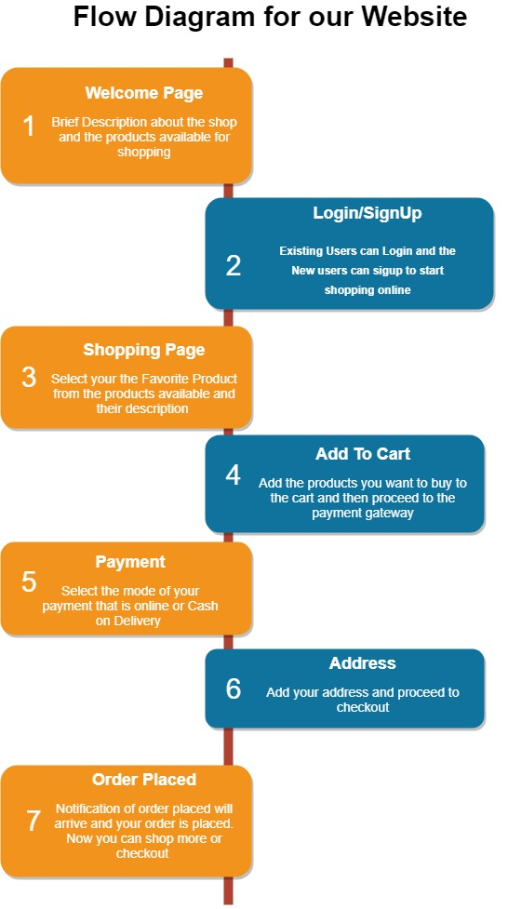

***Outputs***

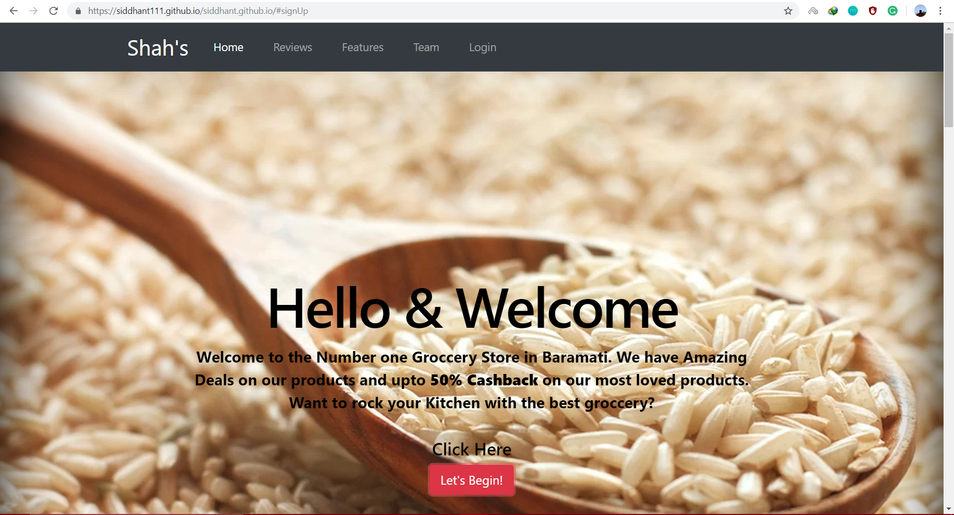

**Welcome Page**

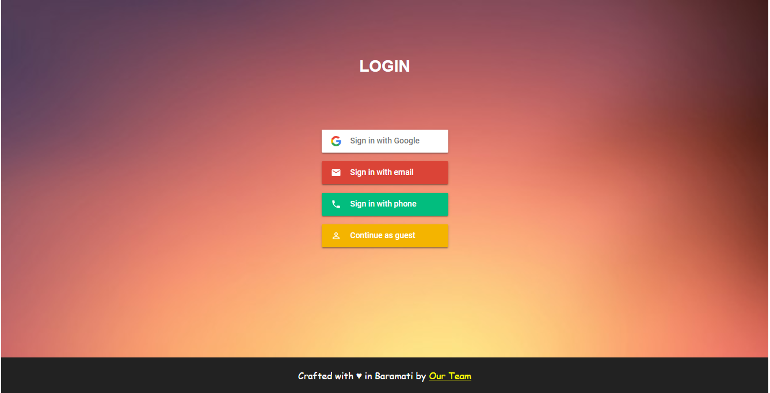

**Login Page**

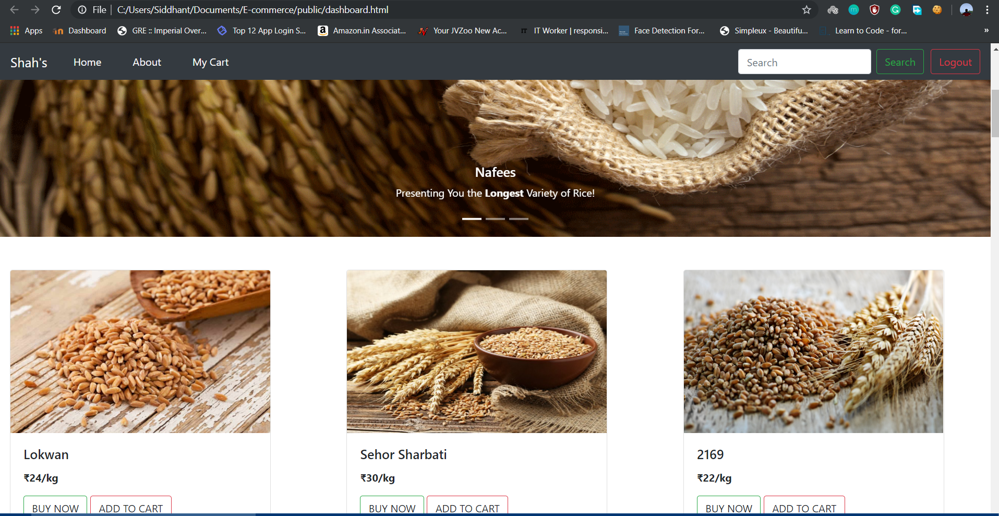

**User Dashboard**



**Products in Dashboard**

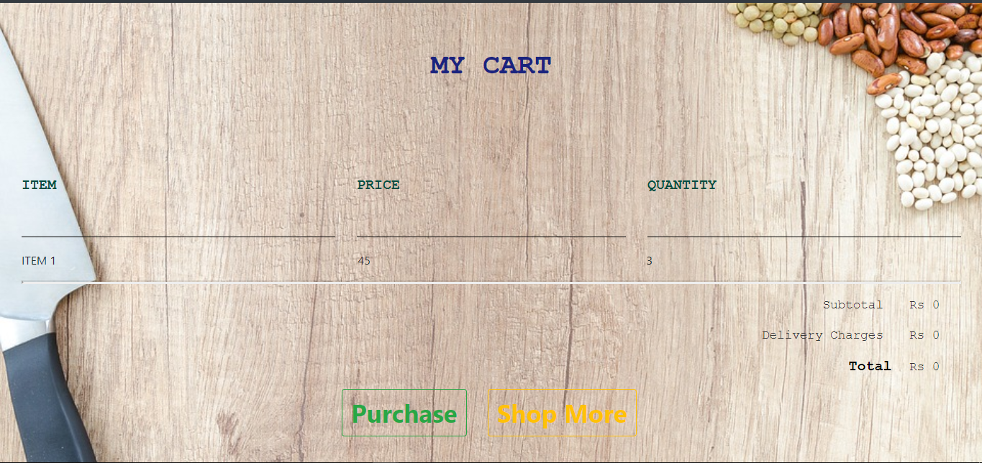

**Cart Page**

***Conclusions and Future Work***

We have developed a responsive E-Commerce website which is fully functional and provide options to login and buy the desired products.

There are some places which need improvement and some features need to be implemented to make this web application more advanced and beneficial to the business.

The future work can mainly be focussed on things like making a fully functional payment gateway for safe payments, introducing an easy return function so that customers can return the product if they are not satisfied with the quality of the product. We can also add a timer which will track the delivery time which in case exceeds the 30 minutes mark then the product will be available at a discounted rate.